ARITHMETIC AND CONVERSIONS IN NUMBER SYSTEM

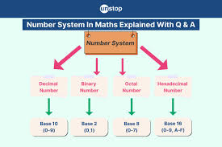
Muhammad Saad Khan
24K-0680

Contents
1.Conversion of decimal number to binary,octal and hexadecimal. 3
1.1 The decimal number is ‘156’. 3
1.2. The Decimal Number is ‘1024’. 4
2.Binary addition and subtraction. 6
2.1. Binary Addition Of (101101+11011). 6
2.2. Binary subtraction of (111001)-(1001). 7
3.Converting fractional binary to it’s decimal equivalent. 8

1.Conversion of decimal number to binary,octal and hexadecimal.

1.1 The decimal number is ‘156’.
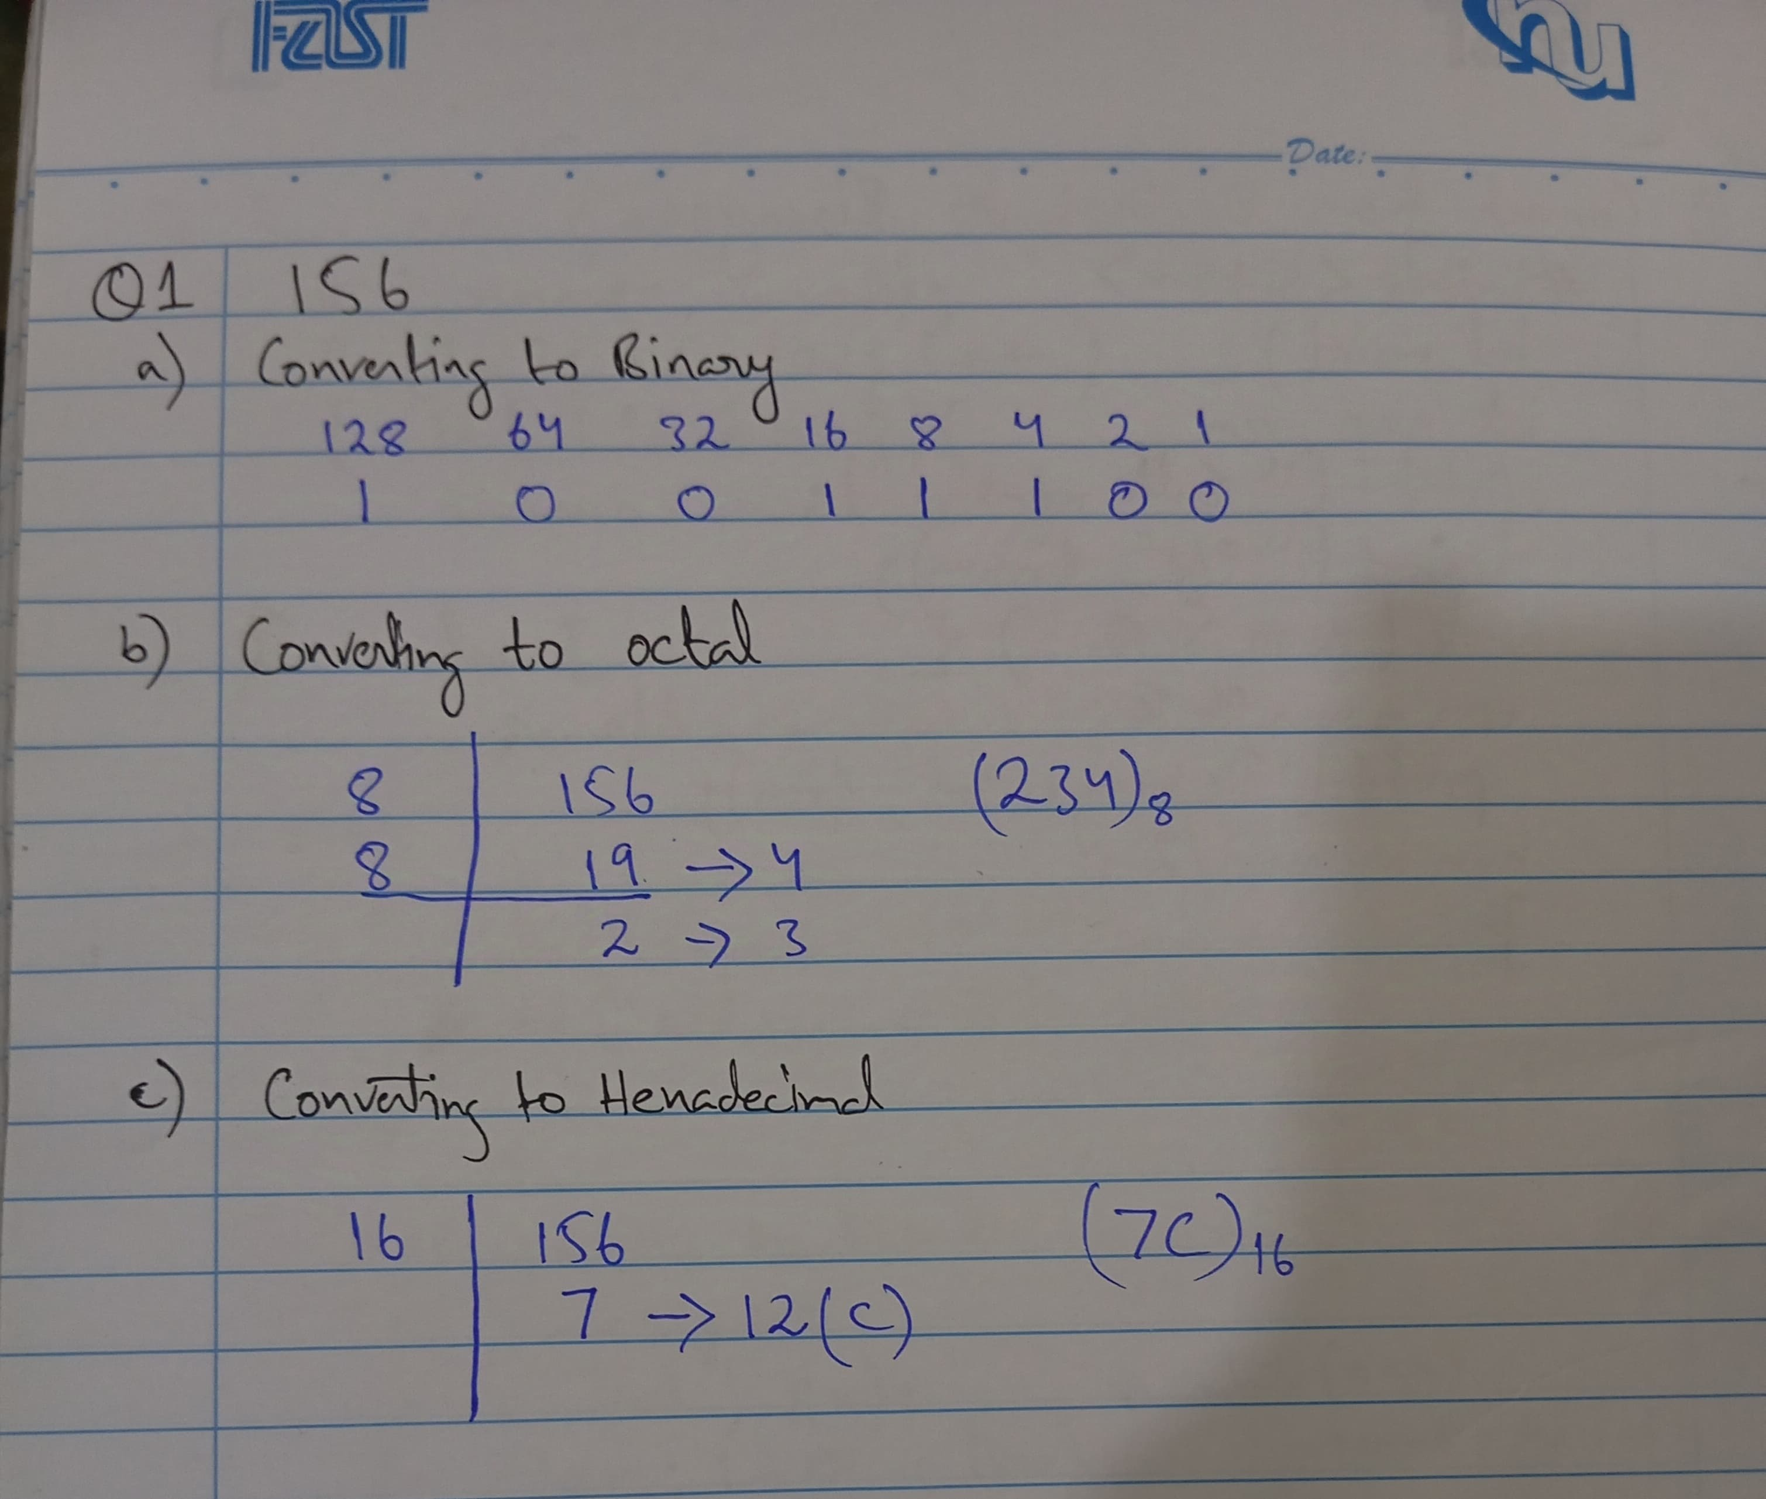

1.2. The Decimal Number is ‘1024’.
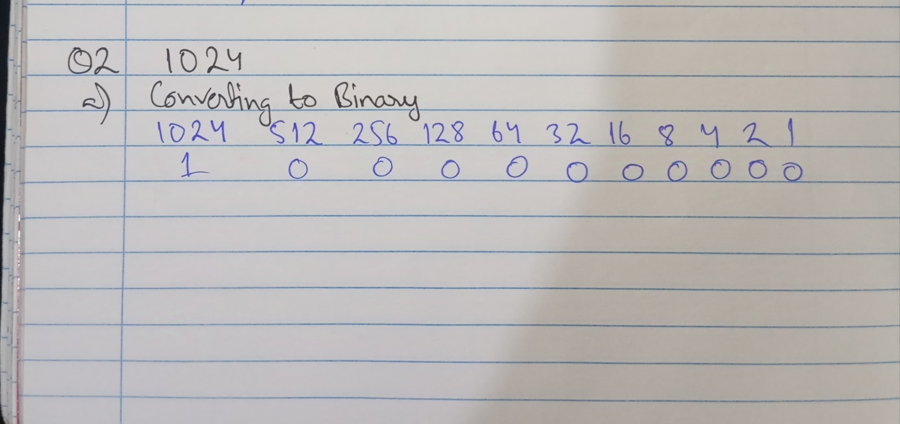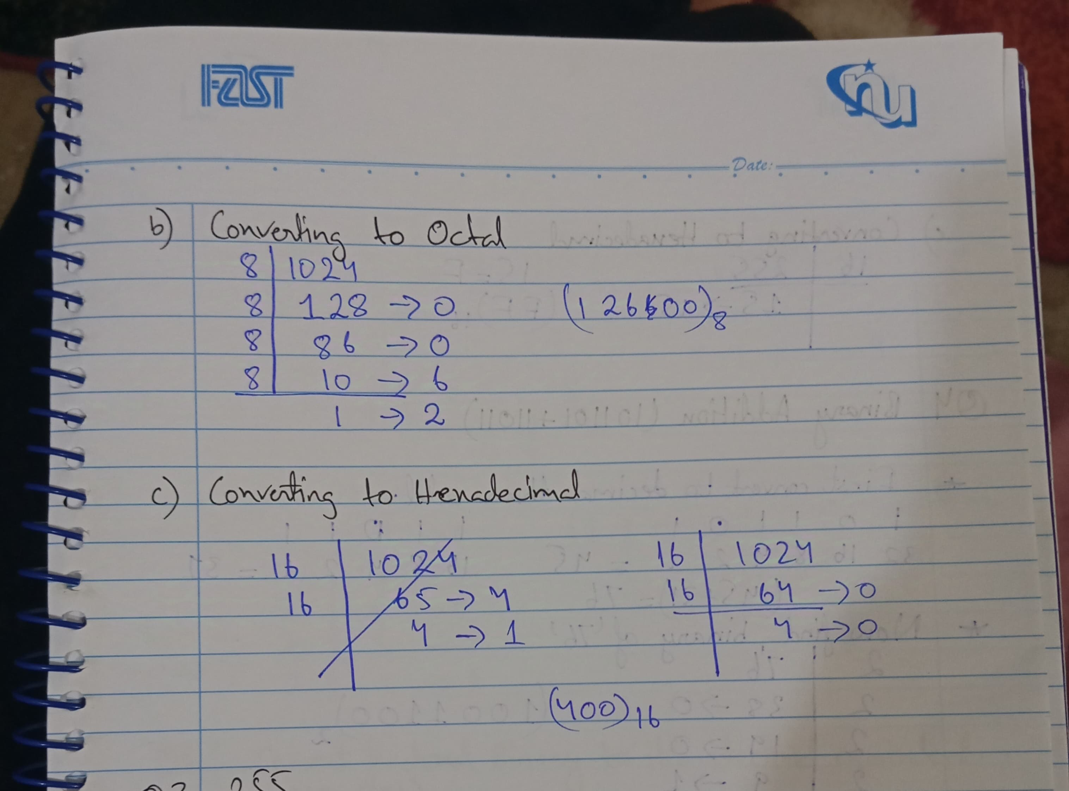

1.3. The Decimal Number Is ‘255’.
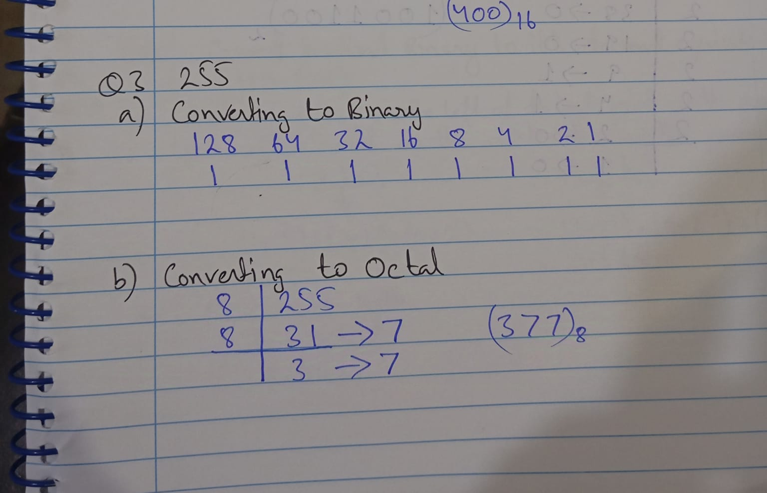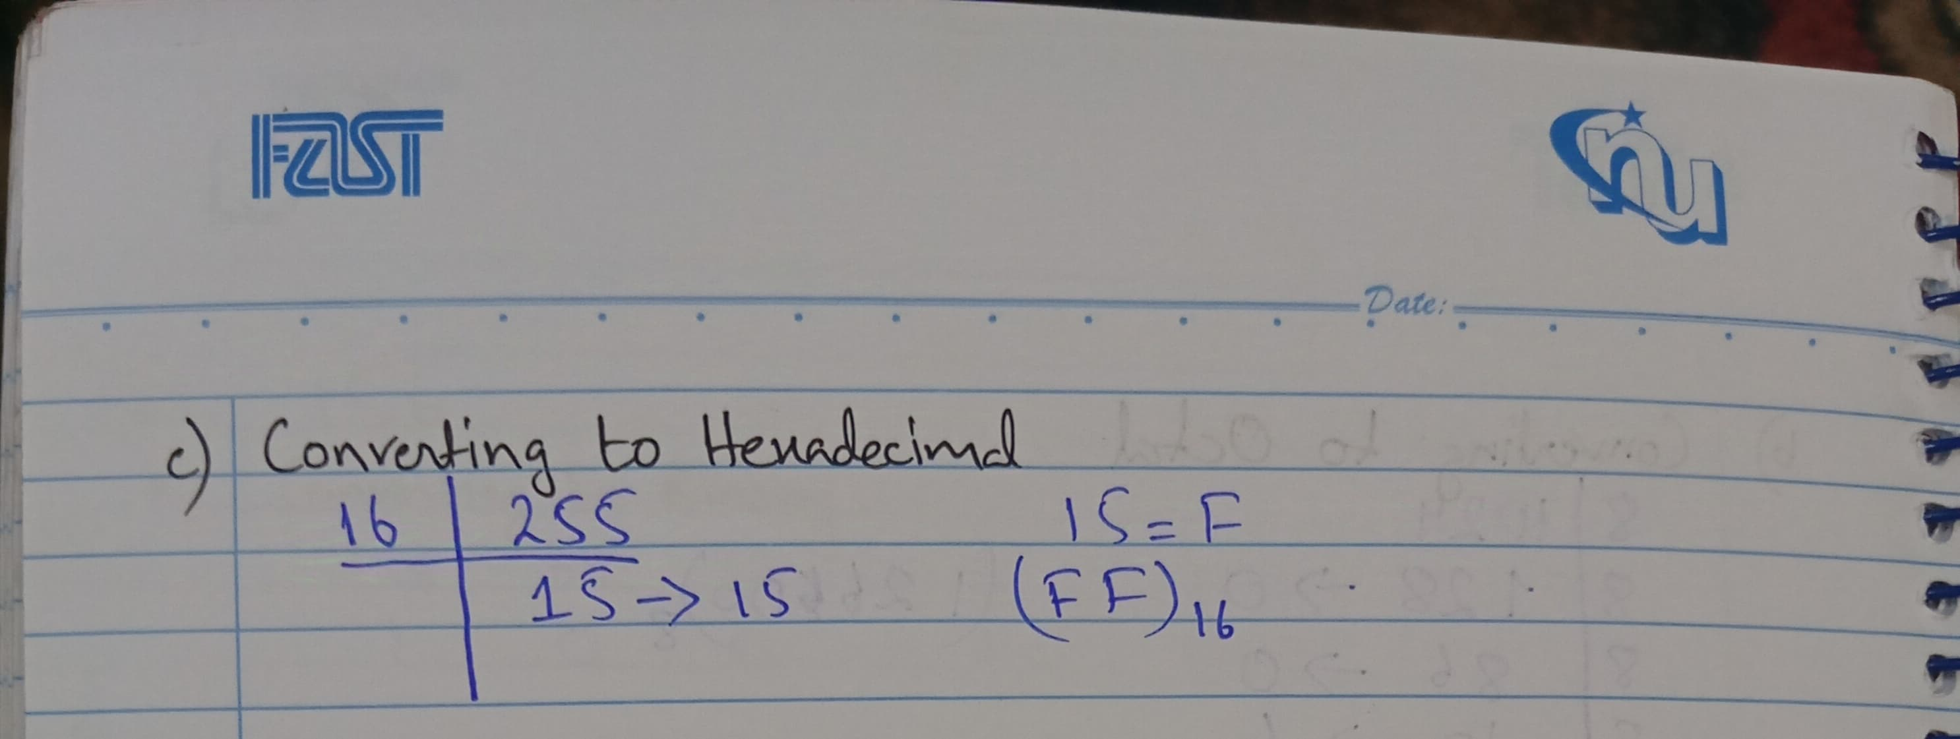

2.Binary addition and subtraction.

2.1. Binary Addition Of (101101+11011).
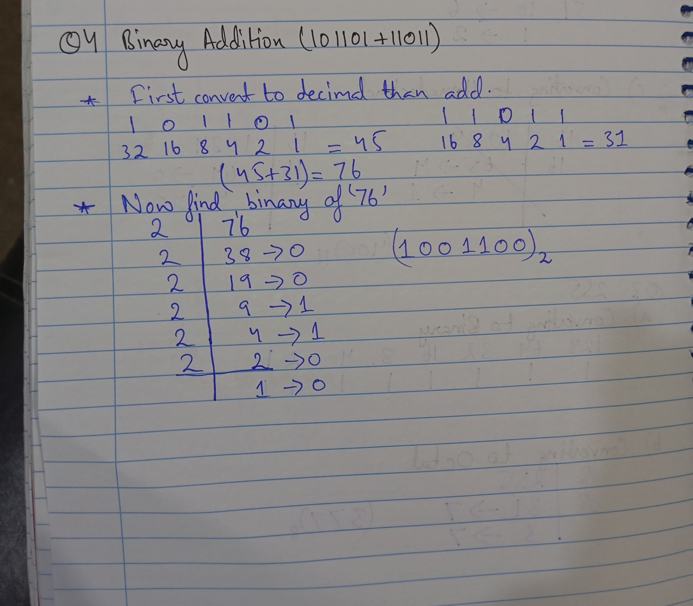

2.2. Binary subtraction of (111001)-(1001).
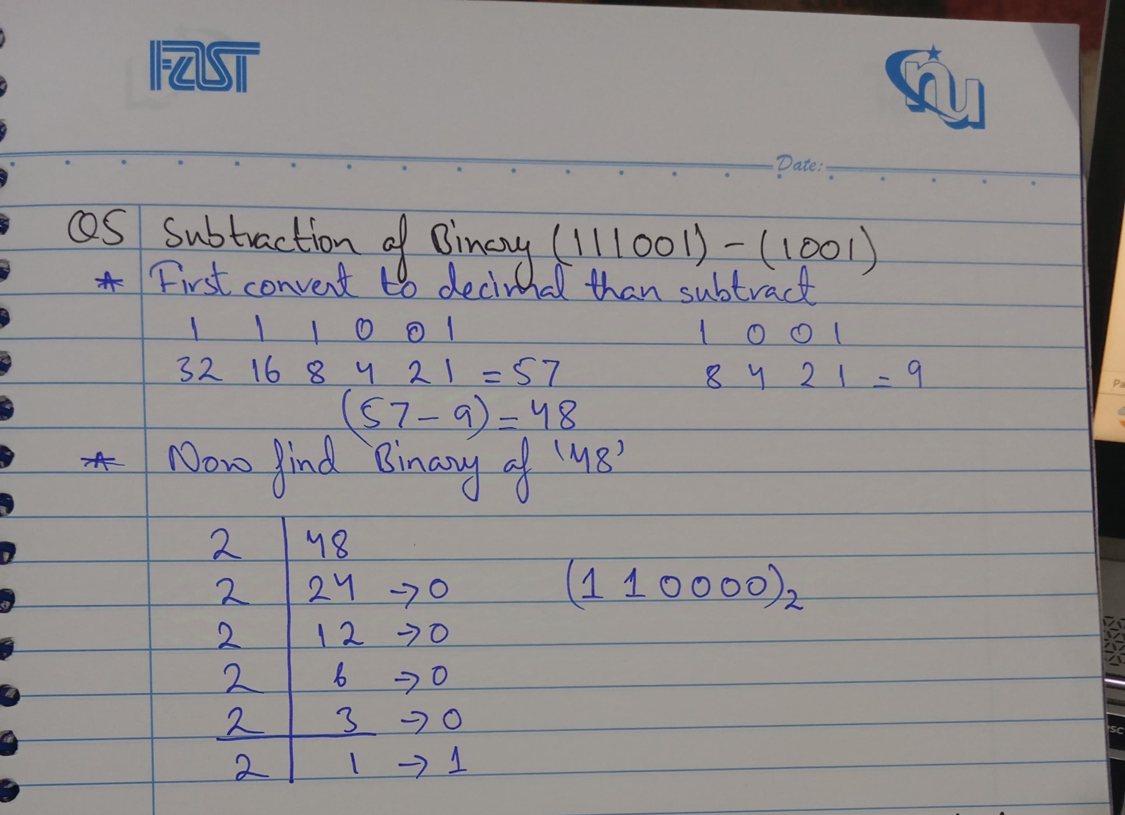

3.Converting fractional binary to it’s decimal equivalent.
